Lesson 5-7 Test
Fruits, Leaves and Roots
Fruits
Multiple Choice: Write the letter of the word that best answers the question.
1. What’s the difference between a fruit and a vegetable? __________________________________________
__________________________________________________________________________________________
_________ 2. Which one is not a way seeds are dispersed?
A. Water B. Wind
C. Pollination D. Mechanical
3. What’s one way an animal disperses seeds? ___________________________________________________
__________________________________________________________________________________________
Are the following plants fruits or vegetables? Write F for Fruit and V for Vegetable
_________ 4. Green bean
_________ 5. Watermelon
_________ 6. Cucumber
_________ 7. Carrot
Leaves
_________ 8. What are the mouths of a leaf called?
A. Bocas B. Stomata
C. Eaters D. Chlorophyll
_________ 9. A leaf takes in ____ from the air and put back ____ into the air.?
A. Carbon Dioxide, Oxygen B. Oxygen, Carbon Dioxide
10. What would happen if a plant lost all of its leaves? ____________________________________________________ __________________________________________________________________________________________________
11.What is the main job of photosynthesis? ______________________________________________________________
12. During Transpiration, what gets released from the leaf? _________________________________________
_________ 13. Along with chlorophyll, carbon dioxide and water—what else does a plant need to go through photosynthesis?
A. oxygen B. shade
C. sunlight D. sugar
_________ 14. The very tip of the leaf is called the _____.
A. Apex B. Midrib
C. Margin D. Blade
Roots
_________ 15. Which is NOT one of the main purposes for roots?
A. Hold plant in place B. Protect ground from erosion
C. Absorb water/nutrients D. Look pretty
_________ 16. How long can root hairs live?
A. 6 weeks B. 6 years
C. 6 days D. 6 seconds
17. How do roots grow? _____________________________________________________________________ __________________________________________________________________________________________
Label the root systems pictured below: Taproot or Fibrous
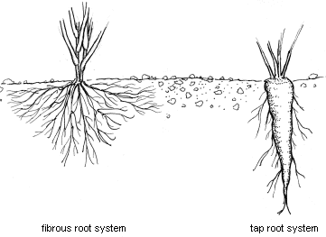
18. ____________________________________ 19. _______________________________________
_________ 20. What kind of geophyte is a potato?
A. Rhizome B. Tuber
C. Bulb D. Corm

